MiSACWIS Project

RM03 – Create-Reopen Resource Screen Specification
Version 1.6

August 27, 2013

Prepared for:


120 N. Washington Square
SACWIS Project, 3rd Floor
Lansing, MI 48933

Prepared by:

Revision Log
Version | Date | A/D/C (Add, Delete, Change) | Author | Document Section # | Description
0.1 | 09/07/2011 |  | Robyn Pratt-Barr |  | Initial version
1.0 | 09/20/2011 |  | Robert LaBarre |  | Approved

1.1 | 09/21/2011 | A/D/C | Mike Stubbs | Field Grid | Quality Assurance Review  Updated Security Requirement Role, Section 2.1.3  Updated: Sections 2.1.3, 3.1.3  Updated information highlighted in yellow.  No functionality affected.
1.2 | 02/15/2012 | C | Robyn Pratt-Barr | Security Requirements | Per CC 4754
1.3 | 12/14/2012 | C | Robert LaBarre | 2.1.3 | Updated per CC #24244
1.4 | 06/17/2013 | C | Mike Stubbs | 2.1.2.1, 2.1.2.3, 2.1.2.4, 2.1.2.5 | CC#33834  Modify BRs to allow linking of inquiries to ‘Active’ Provider records
1.5 | 07/15/2013 | C | Robert LaBarre | 2.1.3 | Updates per CC #39129
1.6 | 08/23/2013 | C | Robert LaBarre | 2.1.2 | Updates per CC #42676

Table of Contents
1 Introduction 5
1.1 Purpose 5
1.2 Scope 5
2 Use Case Details 6
2.1.1 Action Buttons/Hyperlinks 6
2.1.2 Business Rules 7
2.1.3 Security Requirements 15
2.1.4 Screen Navigation 15
2.1.5 Tab Order 16
2.1.6 Pre-Conditions 16
2.1.7 Ticklers 16
2.1.8 Notifications 16
2.1.9 Calendar 17
2.1.10 Reports 17
2.1.11 Notes and Assumptions 17
3 Screen Details 18
3.1 S01 – Provider Name Information Page 18
3.1.1 As Is – Screen Mock Up 18
3.1.2 To Be – Screen Mock Up 19
3.1.3 Screen Fields 20
3.1.4 Action Buttons/Hyperlinks 21
3.1.5 Business Rules 21
3.1.6 Screen Navigation 21
3.1.7 Pre-Conditions 21
3.1.8 Reference Values 21
3.1.9 Notes and Assumptions 22

List of Figures
Figure 1 – Provider Name Information Page – Existing Screen Mock Up 15
Figure 2 – Provider Name Information Page – Updated Screen Mock Up 16

Introduction

Purpose
Reopen or create a new Provider Home record from a Provider Home Inquiry.

Scope
The Create Provider Home Inquiry Record to Provider Home Record use case documents the process to link an Inquiry Record to an existing Provider Home Record, or create a new Provider Home Record (which also links the Provider Home Inquiry to it), and create a Provider Home Record assignment.

Use Case Details

Action Buttons/Hyperlinks
Status (Keep/Add/Modify/Delete) | Label | Type | On Click Action/Navigation
Modify | Add New Provider Home  (Add New Provider) | Button | Open RM04 (Maintain Resource) in add mode, populating the pages with the new data from the Provider Inquiry. The Provider Home record is not created unless an Apply/Save is done on the RM04 screens.
Keep | Close | Button | Close screen and return to the Provider Inquiry list page of RM02.
Keep | Link | Hyperlink | Open RM04 (Maintain Provider) in edit mode, populating the pages with the new data from the Provider Inquiry. The Provider Home record is not updated unless an Apply/Save is done on the RM04 screens.
Keep | Select | Hyperlink | Open RM04 (Maintain Provider in view only mode, displaying the information for the selected Provider Home.

Business Rules
No. | Status (Keep/Add/Modify/Delete) | Business Rule Description | Modified Business Rule Description | Execution Event (field tab out/save etc) | Error Msg Code  To be completed by Development Team
1 | Modify | The grid in the Potential Resource Home Matches groupframe contains all Resource Home records where the ProviderMember.participantID for a Member with a role of Resource Parent, Resource Co-Parent, or Caretaker is equal to one of InquiryParticipant.participantIDs. The list consists only of those Resource Homes with a Status of Closed. | The grid in the Potential Provider Home Matches groupframe contains all Provider Home records where the ProviderParticipant.participantID for a Member with a role of Primary Provider is equal to the Inquirer with the role of Inquirer1. | Screen Open
2 | Modify | Resource Home Inquiries that hat have a Status of Pending Approval (RM02) are the only Resource Inquiries for which the link/search process can be initiated (see RM02). | Provider Home Inquiries that have a Status of Pending Approval (RM02) are the only Provider Inquiries for which the link/search process can be initiated (see RM02). | Screen Open
3 | Modify | When linking to an existing Resource Home record, the system will end date the C/OH/SA Closed Status. | When linking to an existing Provider Home record where the Provider Type is the same as the Inquiry Type , the system will end date the Provider Closed Status with a date = to sysdate -1 and create a new Provider Status record where the effective date = sysdate and the status code = Active. If a non-end dated Provider Status record with a status code = Active already exists, no action needs to be taken. | Link to a Provider Home record.
4 | Modify | The following information is populated in the Resource Home record from a Resource Inquiry record when it is created from or linked to a Resource Inquiry:  The System will use the Inquiry Name of the Resource Home Inquiry Record to populate the Resource Name field in a new Resource Name record; for a RH reopening it will end-date the previous Resource Name record.  The System will use the System date when the link or create action occurs to populate the Begin Date field on the Resource Name record and the Resource Type record.  The System will use the Inquiry Type of the Resource Home Inquiry Record to populate the Resource Type field.  The System will use the Inquiry Sub-Type of the Resource Home Inquiry Record to populate the Resource Sub-Type field.  The System will populate the Current Approval Status (Current Status Code) as Pending Approval.  The System will use the Inquiry Organization of the Resource Home Inquiry Record to populate the Organization information field.  The System will copy forward to the Resource record Address table the attributes from the Resource Inquiry’s Resource Parent’s Address record with a type or Residence (where the primary flag is true), and the most current Mailing address record.  The System will copy forward the attributes from the Resource Inquiry’s Resource Parent’s Contact records. Existing Contact records are deleted. | New Provider Record or Closed Provider Record  The following information is populated in the Provider Home record from a Provider Inquiry record when it is created from or linked to a Provider Inquiry:  - The System will use the Inquiry Name of the Provider Home Inquiry Record to populate the Provider Name field in a new Provider Name record; for a Provider Home reopening it will end-date the previous Provider Name record.  - The System will use the System date when the link or create action occurs to populate the Begin Date field on the Provider Name record and the Provider Type record.  - The System will use the Inquiry Type of the Provider Home Inquiry Record to populate the Provider Type field.  - The System will populate the Current Approval Status (Current Status Code) as Pending Approval.  - The System will use the Inquiry Organization of the Provider Home Inquiry Record to populate the Organization information field.  - The System will copy forward to the Provider record Address table the attributes from the Provider Inquiry’s Inquirer 1 Address record with a type or Residence (where the primary flag is true), and the most current Mailing address record.  - The System will copy forward the attributes from the Provider Inquiry’s Inquirer 1 Contact records. Existing Contact records remains as a historical record.  - The System will copy forward the Preferences (RM02), that were entered, to populate the in the Preferences (RM05) page.  Active Provider Record  The following information is populated in the Provider Home record from a Provider Inquiry record when it is linked to a Provider Record where the Provider Status = ‘Active’:  - The System will  - Use the Inquiry Type of the Provider Inquiry Record to populate the Provider Type field:  - Use the System date to populate the Effective Date field on the Provider Type record;  - Populate the Current Approval Status (Current Status Code) as Pending Approval (along with generating a Provider Type Status record with the same value and effective date = system date).  - Use the Inquiry Organization of the Provider Home Inquiry Record to populate the Organization information field.  The above will only occur if the Provider Type value differs from the current non-end dated Provider Type record. If the Provider Type values are the same, the system will not perform any actions on the Provider Type table. | Link to a Provider Home record, or Create Provider Record.
5 | Modify | The System will copy forward all Inquiry Members as Resource Members with a Begin Date equal to the System date when the link or create action occurs. The Inquiry Roles from the Inquiry Record will populate the Resource Member roles.  NOTE: Users may optionally use the Maintain Members UC to reactivate previous members of the Resource Home, or add additional Members to the Resource Home. | New Provider Record  The System will copy forward all Inquiry Members as Provider Members with a Begin Date equal to the System date when create action occurs. The Inquiry Roles from the Inquiry Record will populate the Provider Member roles, except for the following:  Inquirer 1 will have a role of Primary Provider.  Inquirer 2 will have a role of Secondary Provider.  Closed Provider Record or Active ‘MiSACWIS Provider  If the current status of the Provider Record is ‘Closed’ or the Managed by code for the Provider = ‘MiSACWIS’ then:  The System will copy forward all Inquiry Members not already known to the existing Provider record, as Provider Members with a Begin Date equal to the System date when the link action occurs. The system will reactivate existing Provider Members identified in the inquiry record being linked to the Provider record.  Active “Bridges” Provider Record  If the Managed By Code = ‘BRIDGES’ and the Provider Status = ‘Active’ then no updates should occur to the Provider record.  *Note: These updates need to occur through the RM60 / IF902c transactions or the Provider Home Evaluation.  NOTE: Users may optionally use the RM04f - Maintain Members Use Case to reactivate previous members of the Provider Home, or add additional Members to the Provider Home. | Link to a Provider Home record.
6 | Modify | When the user links a Resource Home Inquiry to an existing Resource Home record, or creates a new Resource Home record from the Resource Home Inquiry, the link hyperlinks on the Potential Resource Match page are not displayed for any of the listed Resource records, and the Add New resource Home button is disabled. | When the user links a Provider Home Inquiry to an existing Provider Home record, or creates a new Provider Home record from the Provider Home Inquiry, the link hyperlinks on the Potential Provider Match page are not displayed for any of the listed Provider records, and the Add New Provider Home button is disabled. | Screen refresh after a link or create operation has occurred. That means that the link or create process was initiated, and the user did a Save/Apply on the RM04 record.
7 | Modify | When the user links a Resource Home Inquiry to an existing Resource Home record, or creates a new Resource Home record from the Resource Home Inquiry, the system changes the Resource Home Inquiry Status to Complete. | When the user links a Provider Home Inquiry to an existing Provider Home record, or creates a new Provider Home record from the Provider Home Inquiry, the system changes the Provider Home Inquiry Status to Complete. | Screen refresh after a link or create operation has occurred. That means that the link or create process was initiated, and the user did a Save/Apply on the RM04 record.
8 | Modify | The following message is presented to the user in a popup:  You are about to create a new Resource Home using this Resource Inquiry. This will also change the Status of the Inquiry to Completed. Once this action is taken, it cannot be reversed, and the Resource Home will be assigned to your workload. Do you want to continue?  If the user elects to continue, the system creates the new Resource Home record. | The following message is presented to the user in a popup:  You are about to create a new Provider Home using this Provider Inquiry. This will also change the Status of the Inquiry to Completed. Once this action is taken, it cannot be reversed, and the Provider Home will be assigned to your workload. Do you want to continue?  If the user elects to continue, the system creates the new Provider Home record. | Selecting the Add New Provider Home button.
9 | Modify | The following message is presented to the user in a popup:  You are about to reopen a Resource Home using this Resource Inquiry. This will also change the Status of the Inquiry to Completed, and will update the Resource Home record with the information from this Inquiry, and the Resource Home will be assigned to your workload. Once this action is taken, it cannot be reversed. Do you want to continue?  If the user elects to continue, the system performs the described actions. | The following message is presented to the user in a popup:  You are about to reopen a Provider Home using this Provider Inquiry. This will also change the Status of the Inquiry to Completed, and will update the Provider Home record with the information from this Inquiry, and the Provider Home will be assigned to your workload. Once this action is taken, it cannot be reversed. Do you want to continue?  If the user elects to continue, the system performs the described actions. | Selecting the link hyperlink for a Provider Inquiry.
10 | Modify | When a Resource Home is opened or reopened, the System generates a "Resource Home Assessment Worker and a Primary Case Manager" assignment role to the user taking the action. | When a Provider Home is opened or reopened, the System generates a "Provider Worker" assignment role to the user taking the action.
11 | Modify | If no Characteristics records exist for the Resource Home, they are pre-filled for the Resource Home based on all of the active Characteristics in the reference table. The scores for all of the Characteristics are Not Selected/Does Not Apply. | If no Characteristics records exist for the Provider Home, they are pre-filled for the Provider Home based on all of the active Characteristics in the reference table. The scores for all of the Characteristics are Not Selected/Does Not Apply. | Link or Create Provider Home

Security Requirements
No. | Status (Keep/Add/Modify/Delete) | Security Requirement
1 | Keep | Create  Inquiry Decision Maker
2 | Keep | Read  N/A
3 | Keep | Update  N/A
4 | Keep | Delete  N/A

Screen Navigation
No. | Status (Keep/Add/Modify/Delete) | To Screen Navigation Path
1 | Keep | Provider>Inquiry>Inquiry List>Potential Provider Home Matches

Tab Order
No. | Status (Keep/Add/Modify/Delete) | Screen name
 | N/A

Pre-Conditions
No. | Status (Keep/Add/Modify/Delete) | Pre-Condition
1 | Keep | A Provider Inquiry with a Status of Pending Approval exists.

Ticklers
Status (Keep/Add/Modify/Delete) | Tickler Name | Trigger Action | Tickler Generation Business Rule & Description | Alert Removal Business Rule | Tickler Text
Status (Keep/Add/Modify/Delete) | Tickler Role
N/A

Notifications
Status (Keep/Add/Modify/Delete) | Notification Name | Trigger Action | Message Business Rule & Description | Message Text
Status (Keep/Add/Modify/Delete) | Notification Role | Trigger Action | Message Business Rule & Description | Message Text
N/A

Calendar
Status (Keep/Add/Modify/Delete) | Calendar Name | Trigger Action | Calendar Event Generation Business Rule & Description | Calendar Event Date and Time Business Rule | Calendar Event Text
Status (Keep/Add/Modify/Delete) | Calendar Role
N/A

Reports

Notes and Assumptions
N/A

Screen Details

S01 – Provider Name Information Page

As Is – Screen Mock Up
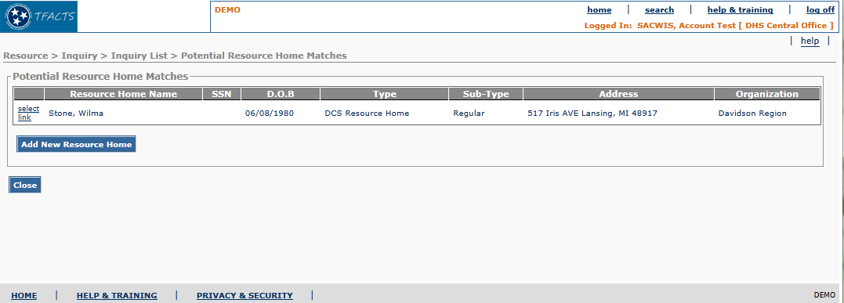
Figure 1 – Provider Name Information Page – Existing Screen Mock Up

To Be – Screen Mock Up
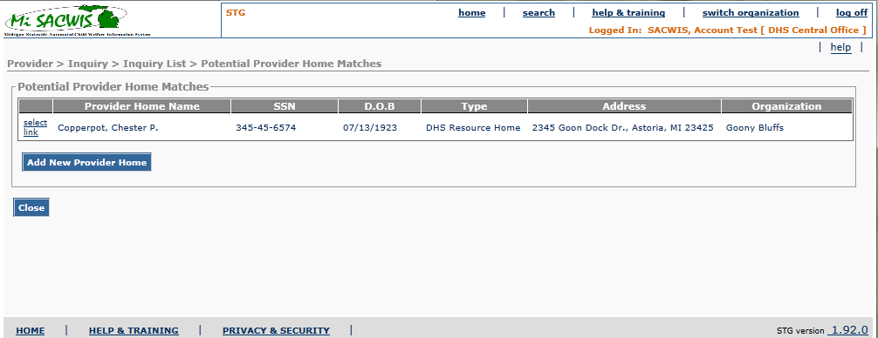
Figure 2 – Provider Name Information Page – Updated Screen Mock Up

Screen Fields
Status (Unchanged/Add/Modify/Delete) | As Is  Class.Attribute Name | To Be  Class.Attribute Name | As Is  Display Name | To Be  Display Name | To Be Type | To Be Align | To Be Size | To Be Read Only | To Be  Calculation | To Be  Edit Mask | To Be UI Validation
Modify | N/A | N/A | Potential Resource Home Matches | Potential Provider Home Matches | Section Header
Modify | Person.lastnamePerson.firstnamePerson.middlename | Person.lastnamePerson.firstnamePerson.middlename | Resource Home Name | Provider Home Name | Display text | L | 100 | T | Use person with Role of Inquirer 1. | Person.lastname+Person.firstname+Person.middlename
Keep | Person.ssn | Person.ssn | SSN | SSN | Display text | L | 11 | T | For person with Role of Inquirer 1 | 999-99-9999
Keep | Person.birthDate | Person.birthDate | DOB | DOB | Display text | L | 10 | T | For person with Role of Inquirer 1 | MM/DD/YYYY
Delete | ProviderType.subTypeCode | N/A | Sub-Type | N/A
Keep | ProviderType.typeCode | ProviderType. typeCode | Type | Type | Display text | L | 100 | T | DomainCode: ProviderType
Keep | ProviderType.agencyId | ProviderType.agencyId | Organization | Organization | Display text | L | 100 | T | Display Agency.agencyName for the Agency indicated by the ProviderType.agencyId

Action Buttons/Hyperlinks
Status (Keep/Add/Modify/Delete) | Label | Type | On Click Action/Navigation

Business Rules
No. | Status (Keep/Add/Modify/Delete) | Business Rule Description | Modified Business Rule Description | Execution Event (field tab out/save etc) | Error Msg Code  To be completed by Development Team

Screen Navigation
No. | Status (Keep/Add/Modify/Delete)

Pre-Conditions
No. | Status (Keep/Add/Modify/Delete) | Pre-Condition

Reference Values
No. | Status (Keep/Add/Modify/Delete) | To Be Class Attribute | Domain Code | Short Desc | Ref Data Code
1

Notes and Assumptions
N/A

